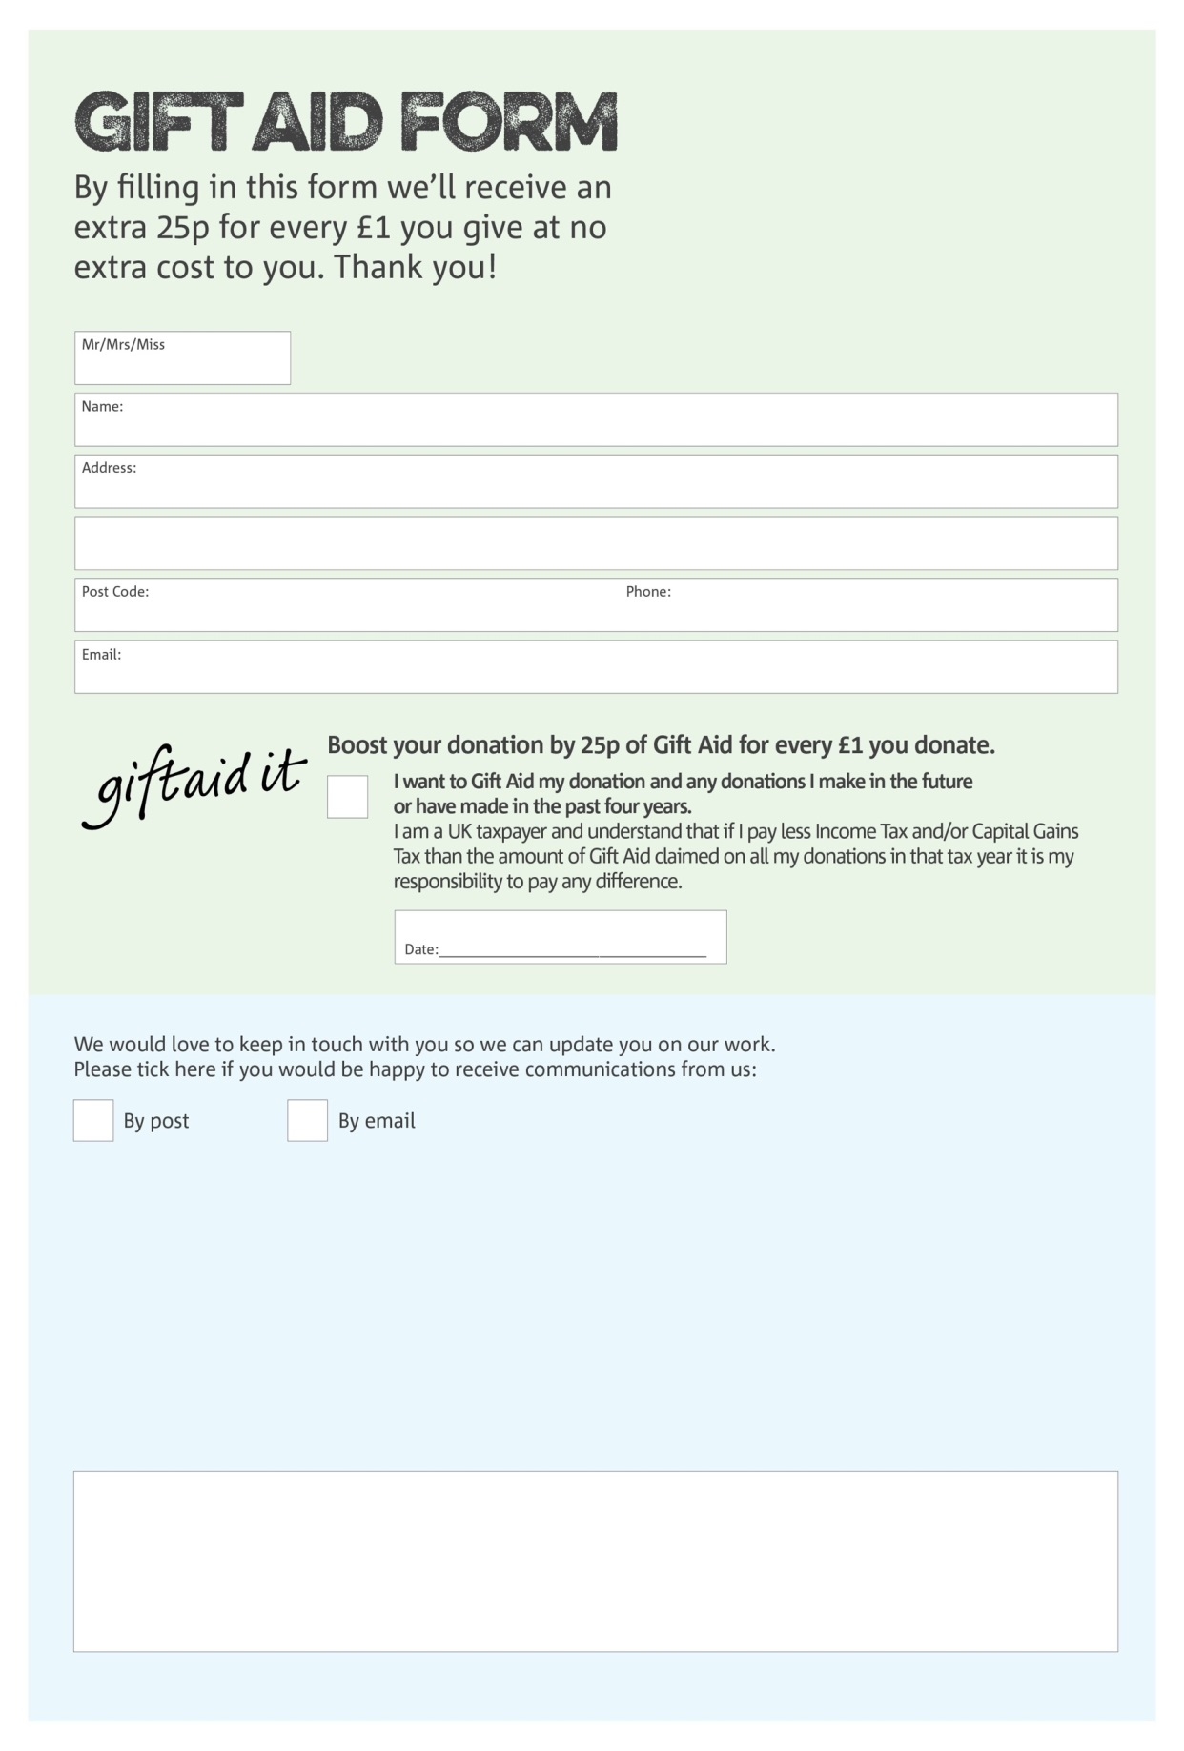

**Data protection**

Bedford Foodbank is committed to protecting your privacy and will process your personal data in accordance with the Data Protection Act 1998. Bedford Foodbank collects information to keep in touch with you and supply you with information relating to our work. Bedford Foodbank will never sell or pass your details to anyone who isn’t directly working on our behalf.

Charity Number 1041488. Registered in 1994

We would love to know why you have chosen to donate to Bedford Foodbank. If you would like to share your motivation let us know below:

You can change your preferences any time by contacting us on 01234 268569 or emailing us at info@bedford.foodbank.org.uk



Signature:-